Dear Parent/Carer,

As a healthy school, we believe that developing our children’s understanding of the importance of physical activity is essential. To achieve this we ensure that our pupils participate in at least 2 hours of PE each week and have access to a range of extracurricular physical activity. During the school day, children also participate in the Daily Mile. This is not PE, sport or cross-country but physical activity in a social setting, which is aimed at improving the children’s physical, social, emotional and mental health, and wellbeing. The children jog or walk at their own pace in the fresh air. We have found that this has helped children to focus and concentrate in the classroom making them more learning-ready and most importantly, the children really enjoy it.

Over the last couple of years, we have used Yourtrak to encourage children to participate in the Daily Mile and develop their fitness and stamina. They were able to see their progress by collecting miles and earning marathon certificates. Unfortunately, Yourtrak are no longer running this programme but keen to continue to promote the Daily Mile, we have decided to launch the Elmridge Globe Trotter initiative.

Children will be able to track their progress and celebrate their achievements. The more laps they complete, the further around the world they will travel. They will receive certificates as they build their miles and will be able to plot their journey around the world. They will also know how many miles they have accumulated from since first embarking on the challenge. Children will not lose the miles that they have already achieved, but pick up where they left the Yourtrak scheme. As a school, we are excited about this new initiative and we are looking forward to the benefits it will bring to the children. We hope you will enjoy sharing this with your children.
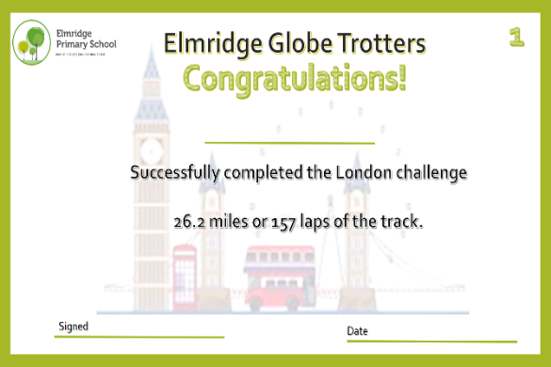

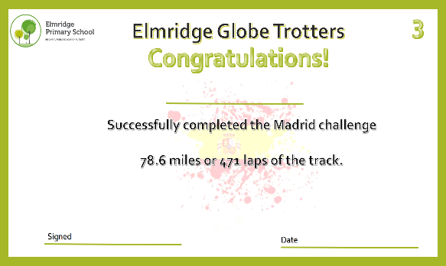
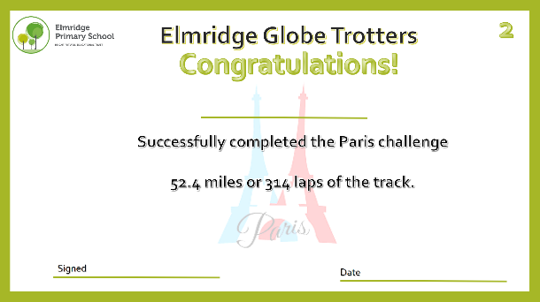

Kind regards,

Mrs Zoe Pilkington
Deputy Headteacher

