“Unlocking potential, inspiring success, celebrating diversity”

Our School Values
Collaboration  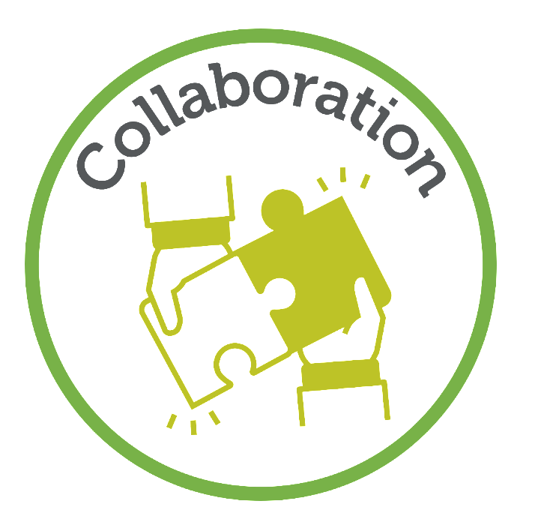 | Challenge  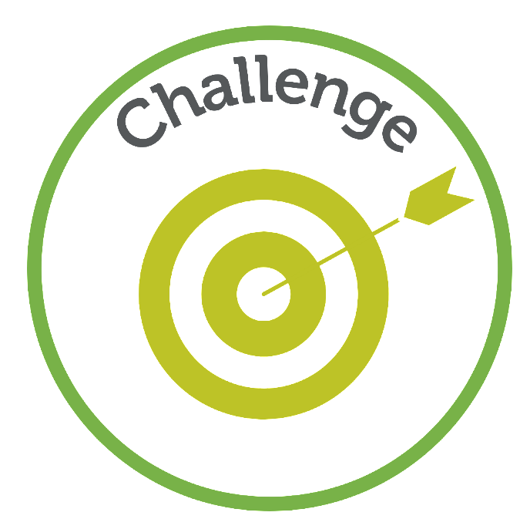 | Compassion  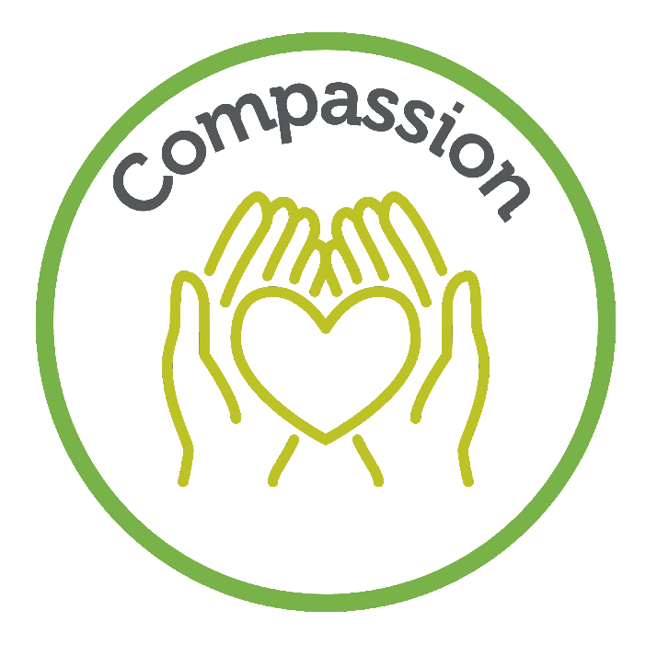

Our Curriculum Threads
International Learners | Aspirational Leaders | Literacy Champions

Characteristics of Effective Learning
Playing and exploring: - Children investigate and experience things, and ‘have a go’. Children who actively participate in their own play develop a larger store of information and experiences to draw on which positively supports their learning
Active learning: - Children concentrate and keep on trying if they encounter difficulties. They are proud of their own achievements. For children to develop into self-regulating, lifelong learners they are required to take ownership, accept challenges and learn persistence.
Creating and thinking critically: - Children develop their own ideas and make links between these ideas. They think flexibly and rationally, drawing on previous experiences which help them to solve problems and reach conclusions.

 | Autumn 1 | Autumn 2 | Spring 1 | Spring 2 | Summer 1 | Summer 2
Topic | All about me | Sparkle & Shine | 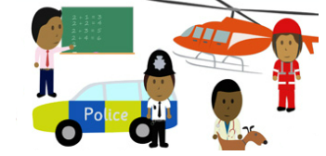  People Who Help Us | Minibeasts  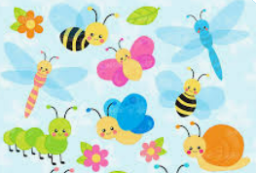 | 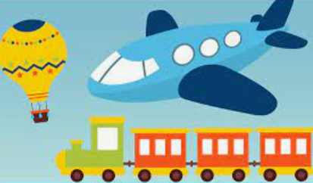  Transport and Travel | Under the Sea  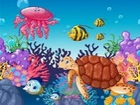
Overview | Transition from home family to school family. | Exploring Seasonal changes and seasonal celebrations. | Exploring who helps us in our community. | Exploring which minibeast we can find at school and how do they change and grow. | Exploring different vehicles and how they move. | Exploring the different creature who live beneath the sea.
Weekly Themes | Settling in  Feelings and regulations Identifying who we are and our families  Body parts  Autumnal changes  Harvest | Bonfire night  Diwali  Seasonal changes – Autumn to winter  Hanuakkah  Christmas | Doctors, Nurses, and Vets  Dentists  Police and Fire service  Chinese New Year  Valentine’s Day  Pancake day | Different Minibeasts and their habitats  Lifecycle of a butterfly  World Book Day  Plant and take care of plants and Vegetables.  Seasonal Changes  Holi Festival | Different types of transport  How do you travel to school? Map drawing  Where do you travel in your community?  St Georges Day  Space | Under the sea creatures  Sinking and floating  Keeping our sea clean  The seaside  Pirates  Summer  Eid
Super Six Books | The Colour Monster  Worrysaurus  Happy in our skin  Families around the world  Funny Bones  The Leaf Thief  The Enormous Turnip | The best Diwali ever  Pumpkin soup  We’re going on a leaf hunt  The Owl who was Afraid of the Dark  The gingerbread man  The Jolly Postman’s Christmas | A Superhero like You  Emergency!  Doctorsaurus  Winnie & Wilbur at Chinese New Year  Mr Wolfs Pancakes  Guess How Much I Love You | Superworm  What the ladybird heard  The Very Hungry Caterpillar Bumblebear  Do you love bugs?  Hello Spring | Things that go!  Naughty Bus  Emma Jane’s Aeroplane  Martha Maps it out  Toys in Space  The Smeds and the Smoos | The Big Book of Blue  Commotion in the Ocean  Rainbow Fish  Sharing a Shell  Billy’s Bucket
Rhyme Time | If your happy and you know it  Head, shoulders knees & Toes  I’m a dingle dangle scarecrow | Twinkle Twinkle Little Star  The leaves are falling down  I‘m a little hedgehog | 999 Emergency  London Bridge is falling down  Miss Polly had a dolly | Incy Wincy Spider  Ladybird Ladybird fly away home  The Ants Go marching  Down at the bottom of the garden  5 Hot Cross Buns | Wheels on the Bus  Five Little Firemen  Down at the Station  Hey Diddle Diddle  Five Little men flying in a saucer | 1,2,3,4,5 once I caught a fish alive  Row, Row, Row your boat  When I was one! (Pirate song)  A Sailor went to See
Experiences | Grandparents Day Birds of Prey Visit | Autumn Welly Walk | Fire brigade visit | Live caterpillars | Walk around the local area  Altrincham Bus Station | Blue Planet Aquarium
Assessment Opportunities | Home Visits  Baseline  WellComm (SALT) Assessments | Data Point 1  Pupil progress Meetings | LW Phonics Assessment | Data Point 2  Pupil progress Meetings  LW Phonics Assessment | LW Phonics Assessment | LW Phonics Assessment  Data Point 3  Pupil progress Meetings
Parental Involvement | Stay and play | Parents’ Evening  Nativity Performance  Phonics Workshop | Maths Workshop | Parents’ Evening  Fine Motor skills Workshop | C&L Workshop | Moving on Up Week – stay and play

 | Autumn 1 | Autumn 2 | Spring 1 | Spring 2 | Summer 1 | Summer 2
Topic | All about me | Sparkle & Shine | People Who Help Us | Minibeasts | Transport and Travel | Under the Sea
Communication & Language | The development of children’s spoken language underpins all seven areas of learning and development. Children’s back-and-forth interactions from an early age form the foundations for language and cognitive development. The number and quality of the conversations they have with adults and peers throughout the day in a language-rich environment is crucial. By commenting on what children are interested in or doing, and echoing back what they say with new vocabulary added, practitioners will build children's language effectively. Reading frequently to children, and engaging them actively in stories, non-fiction, rhymes and poems, and then providing them with extensive opportunities to use and embed new words in a range of contexts, will give children the opportunity to thrive. Through conversation, story-telling and role play, where children share their ideas with support and modelling from their teacher, and sensitive questioning that invites them to elaborate, children become comfortable using a rich range of vocabulary and language structures.
 | * To understand and follow simple instructions.  * To recognise and point to objects on request.  * To focus on an activity of my choice.  * To identify familiar objects and properties when they’re described.  * To be directed to an activity by an adult.  * To understand and follow a 2 key word instruction.  * To use intonation, pitch and different volumes when ‘talking’.  * To make eye contact for longer periods.  * begin to link four or five words together.  * To use the speech sounds p, b, m, w.  * To use ‘words’ to make myself understood.  * To use ‘what’ questions. | * To listen to simple stories and understand what is happening, using the pictures.  * To listen to others when they speak.  * To identify action words by pointing to the right picture.  * To understand simple concepts (e.g. big/little, open/shut).  * I am beginning to answer ‘who’, ‘what’ and ‘where’ questions.  * To use the pronouns (me, him, she).  * To use the prepositions (in, on, under) | * To remember ‘what happens’ in longer stories.  * To understand and follow a three key word sentence.  * To switch attention between listening to a speaker and my focus on a task.  * To understand the use of objects.  * To use sentences of four to six words.  * To articulate multi-syllabic words.  * To use ‘and’, ‘because’ to link my sentences.  * To use language to retell a simple past event in the correct order.  * To start a conversation with an adult or a friend and continue it for many turns.  * To use talk to organise myself and my play. | * To understand ‘why’ questions.  * To understand and follow a question or instruction that has two parts.  * I enjoy listening to longer stories.  * I understand prepositions such as ‘under’, ‘on top’, ‘behind’.  * To use future tense.  * To pronounce: l,w,y, s,dz.  *To use ‘where’ and ‘who’ questions.  * To use a wider range of vocabulary in my play and interactions, which is linked to knowledge, skills and technical language in all areas of learning and development. | *To listen carefully and talk about why listening is important.  * To join in at group time by putting up my hand and waiting for my turn to talk.  * To understand and answer ‘how’ questions.  * To use past tense.  * To question why things happen.  * To pronounce: r, j, th, ch, and sh.  * To articulate multi-syllabic words such as ‘pterodactyl’, ‘planetarium’ or ‘hippopotamus’. | *To focus on a chosen activity for at least ten minutes.  * To sit quietly and listen for fifteen minutes.  * To move away from distractions when concentrating.  * To understand when asked questions like “Why do you want to go to the beach?”.  * To express a point of view and debate when I disagree with an adult or a friend.  * To use a wider range of vocabulary in my work, which is linked to knowledge, skills and technical language in all areas of learning and development.

 | Autumn 1 | Autumn 2 | Spring 1 | Spring 2 | Summer 1 | Summer 2
Topic | All about me | Sparkle & Shine | People Who Help Us | Minibeasts | Transport and Travel | Under the Sea
Personal, Social & Emotional Development | Children’s personal, social and emotional development (PSED) is crucial for children to lead healthy and happy lives, and is fundamental to their cognitive development. Underpinning their personal development are the important attachments that shape their social world. Strong, warm and supportive relationships with adults enable children to learn how to understand their own feelings and those of others. Children should be supported to manage emotions, develop a positive sense of self, set themselves simple goals, have confidence in their own abilities, to persist and wait for what they want and direct attention as necessary. Through adult modelling and guidance, they will learn how to look after their bodies, including healthy eating, and manage personal needs independently. Through supported interaction with other children, they learn how to make good friendships, co-operate and resolve conflicts peacefully. Through weekly Think Equal sessions, children will be exposed to a range of stories and activities to support children with their Self-Regulation, Managing Self and Building Relationships. These attributes will provide a secure platform from which children can achieve at school and in later life.
Managing Self  Self-regulation  Making Relationships | *To express my emotions; happy, sad, excited, cross, tired, frustrated, upset.  * To find out about emotions through stories.  * To take turns with other children, with adult support.  * I am starting to show ‘effortful control’.  * To explore the classroom with adult support.  * To use the toilet with prompts and support.  * To wash and dry my own hands with prompts.  * To separate from my parent with some support.  * To notice differences between others and myself.  Think Equal:  Me, Myself and I  Is there Anyone like me?  Amazing Daisy  Healthy Minds A  The colour poem | * I will have a ‘go’ at new activities.  * To show good sitting, good listening, good looking, keeping hands and feet to themselves at group times.  * To look after the toys and equipment and help to tidy up.  * To play alongside other children without adult support.  * To play simple turn taking games with adult support.  * I am showing interest in the other children’s play.  Think Equal:  How we feel  Wally the Wave  Healthy Minds B  I have a plan  The wall | * To talk about my feelings.  * To wait for my turn.  * Develop confident when exploring new places in the school building.  * To use the visual timeline to understand the daily routine.  * To make a clear choice about where to play.  * To be a responsible  * To tidy up resources that I’ve used.  * To enter the classroom without adult support at the start of the day.  * To use the toilet independently.  * To take part in new experiences confidently.  * To follow all of the Nursery expectations.  * To talk about myself and my family.  * To respond to what others are saying or doing in play  * To show friendly behaviour with peers and familiar adults.  Think Equal:  The tale of Baby Beetroot  Lara the Yellow Ladybird  My Voice  Healthy Minds C  Kitchi’s Moccasins | * To select and use activities and resources, to achieve a goal that I’ve chosen.  * To talk about my feelings in more elaborated ways.  * To manage my feelings when angry, upset or worried.  * To ask for help when I have a conflict.  * To stay focused on a task for a longer period of time  * To talk about why I need to clean my teeth and how to do this.  * To talk about healthy food choices.  * I am more confident in new social situations.  * To initiate my own play activities and play happily with one or more child.  Think Equal:  Helping Hands  Diego’s Great idea  Head, heart and Hands  My Amazing Brain  Healthy Minds D | * To manage my emotions and show effortful control.  * To think about how others might be feeling and why.  * To try to help if someone is upset or angry.  * To solve conflicts with others.  * I am showing more confidence in new social situations.  * To cope with small changes in the daily routine.  * To follow the Nursery rules unprompted.  *To talk about why the Nursery rules are important.  * To talk about why we wash our hands throughout the day.  * To make up games to play with friends.  * To extend and elaborate play ideas.  Think Equal:  Home  A time to be Noisy  I love my planet  Anjali’s Kite  Healthy Minds E | * To talk to unfamiliar people.  * Begin to see different points of view.  * To talk about moving to a new class and year group.  * To Identify healthy foods.  * To talk about how we keep our bodies healthy.  * To talk about what happens if we don’t clean our teeth or visit the dentist.  * To Initiate conversations and take account of what others say.  * To find solutions to quarrels  Think Equal:  Sizwe’s Smile  My special hair  My mum loves me so much / my dad loves me so much  Healthy Minds F  Caring Animals: Lalela Books

 | Autumn 1 | Autumn 2 | Spring 1 | Spring 2 | Summer 1 | Summer 2
Topic | All about me | Sparkle & Shine | People Who Help Us | Minibeasts | Transport and Travel | Under the Sea
Physical Development | Physical activity is vital in children’s all-round development, enabling them to pursue happy, healthy and active lives. Gross and fine motor experiences develop incrementally throughout early childhood, starting with sensory explorations and the development of a child’s strength, co-ordination and positional awareness through tummy time, crawling and play movement with both objects and adults. By creating games and providing opportunities for play both indoors and outdoors, adults can support children to develop their core strength, stability, balance, spatial awareness, co-ordination and agility. Gross motor skills provide the foundation for developing healthy bodies and social and emotional well-being. Fine motor control and precision helps with hand-eye co-ordination, which is later linked to early literacy. Repeated and varied opportunities to explore and play with small world activities, puzzles, arts and crafts and the practice of using small tools, with feedback and support from adults, allow children to develop proficiency, control and confidence.
Fine Motor | * To use my manipulative skills and control, to draw freely, including scribbling, ‘colouring’.  * To grip writing implements, using a palmar grip or five-finger group.  * To explore different materials and tools, making controlled marks in sand, shaving foam, using large chalk, paint easel.  * To hold and grasp different materials; spoons, brushes, shells, clay, jelly, dough.  * To finger feed myself and drink from an open cup. | * To hold different types of paper and learn how to tear it.  * To use large and small motor skills to do things independently, for example remove my shoes, undoing velcro and zips on coats.  * To use a fork and spoon to take food from a plate/bowl to my mouth. | * To make conscious marks and pretend writing.  * To use one-handed tools and equipment; snips in paper, hammer pins into a board, push straws through holes, and put pegs into pegboards.  * To use a preferred hand.  * To manipulate dough in different ways; rolling, squashing, squeezing, patting using their hands. | * To use one-handed tools and equipment; use tweezers to pick up small objects, squeeze a clothes peg and attach to a string line.  * To use a two finger and thumb grip.  * To put on my coat independently.  * To make controlled marks: e.g., enclosures, lines, dots, dashes, back and forth scribbles and circling. | * To begin to use scissors to cut along a line.  * To use a knife to cut my own food at lunchtime, with some support.  * To cut soft things with a knife for example a banana or dough.  * To fasten my own coat.  * To thread small beads onto a string.  * To copy shapes and patterns using increasingly precise tools. For example; drawing triangular patterns/shapes with a paintbrush. | * To use a two finger, one thumb grip for appropriate activities/ tools.  * To form the letters in my first name correctly when tracing over.  * To take off and put on my own shoes and socks after an activity.  * To eat use a knife, fork and spoon appropriately.
Gross Motor | * To clap and stamp to music.  * To sit in a balanced position.  * To fit myself into spaces, like tunnels, dens and large boxes, and move around in them.  * To build independently with a range of appropriate resources.  * To move by walking and running.  * I am beginning to jump and climb.  * To sit on a push-along wheeled toy, to scoot along.  * To sit on a tricycle and use my feet on the floor to move around  Get Set 4 PE  Fundamental skills  All About Me  Children develop the skills of balancing, running, changing direction, jumping, hopping and travelling. They develop gross motor skills and learn how to stay safe using space, working independently and in pairs. | * *To run confidently at different speeds; fast and slow.  *To show control of my whole body through continual practice of large movements, such as waving, kicking, rolling, crawling and walking.  * I am beginning to scoot along on a scooter.  * To spin, roll and independently use ropes and swings.  * To hop on one leg.  * To skip with two legs confidently.  Get Set 4 PE  Fundamental skills  Adventure  Children learn principles of finding space, freezing, using and sharing equipment. They develop the skills of running, jumping and skipping. | * To change direction to avoid obstacles and other children when walking.  * To balance on a range of equipment, including planks.  * To go up steps and stairs, including climbing on/up apparatus, using alternate feet.  * To balance and stand on one leg.  * To use large-muscle movements to wave flags and streamers, paint and make marks.  * To walk on different parts of my feet; tiptoes, heels.  * To walk across a plank at different heights in different ways safely and with confidence.  * To climb safely, showing an awareness of risks and talking about them.  Get Set 4 PE  Gymnastics  Animals and Habitats  Children explore basic movement, creating shapes, balances, and jumps and begin to develop rocking and rolling. They safely and perform basic skills on both floor and apparatus. They copy, create, remember and repeat short sequences beginning to use levels. | * To change direction to avoid obstacles and other children when running.  * To take part in group activities that I make up or in teams.  * To collaborate with others to manage large items, such as moving a long plank safely.  * To throw beanbags and balls using an underarm and overarm throw.  * I am starting to catch large balls.  * To roll a ball to a friend and engage in a simple game.  * I am starting to kick and throw large balls.  * To catch a large ball with two hands.  * To engage in a ‘throw and catch’ game with a peer using a ball or beanbag.  Get Set 4 PE  Ball skills  Mini beasts  Children develop rolling and receiving a ball, throwing to a target, bouncing and catching, dribbling with feet and kicking a ball. They develop their fine and gross motor skills through a range of game play using a variety of equipment alone and in pairs. | * To walk backwards avoiding obstacles.  * To jump off apparatus safely, landing on both feet.  * To ride a tricycle, scooter, scoot board independently with confidence around a track.  * To freeze my position when dancing on request.  * To move in a variety of ways; rolling, crawling and sliding.  * To work with others to manage large items such as planks and blocks without support from an adult.  Get Set 4 PE  Games - Transport  Children develop their understanding of playing games and further develop fundamental movement skills. They learn how to score and play by the rules, how to work with a partner and begin to understand what a team is, as well as learning how to behave when winning and losing. | *To balance and ride on a trundle bike independently with confidence around a track.  * To choose the right equipment to do a challenge safely.  *To ‘freeze’ my body when the music stops, when playing games.  * To use and remember sequences and patterns of movements which are related to music and rhythm.  * To ask others to help solve a challenge that I am struggling with.  * To play ring games and games with the parachute.  * To join in with action songs  * To initiate a ring game; The farmers in his den, Ring ‘o’ roses  Get Set 4 PE  Dance - Journeys  Children develop their expressive movement. They explore travelling movements, shapes and balances. They choose their own actions in response to a stimulus. They copy, repeat and remember actions. They are introduced to counting to help them keep in time. They perform to others and begin to provide simple feedback.

 | Autumn 1 | Autumn 2 | Spring 1 | Spring 2 | Summer 1 | Summer 2
Topic | All about me | Sparkle & Shine | People Who Help Us | Minibeasts | Transport and Travel | Under the Sea
Reading | It is crucial for children to develop a life-long love of reading. Reading consists of two dimensions: language comprehension and word reading. Language comprehension (necessary for both reading and writing) starts from birth. It only develops when adults talk with children about the world around them and the books (stories and non-fiction) they read with them, and enjoy rhymes, poems and songs together. Skilled word reading, taught later, involves both the speedy working out of the pronunciation of unfamiliar printed words (decoding) and the speedy recognition of familiar printed words. Writing involves transcription (spelling and handwriting) and composition (articulating ideas and structuring them in speech, before writing).
Comprehension  - Developing a passion for reading | * begin to understand books have words and pictures.  * To turn the pages one at a time..  * To point to a picture in a book.  * To match pictures to pictures and symbols to symbols.  * To point to a named character in a familiar book.  * To listen to a simple story and understand what is happening with the help of the pictures.  * I enjoy sharing books with an adult.  * To pay attention and respond to the pictures or the words.  *To begin to recognise my name with picture  * To join in with songs and rhymes, copying sounds, rhythms, tunes and tempo.  * To say some of the words in songs and rhymes | * I have favourite books and seek them out, to share with an adult, with another child, or to look at alone.  * To join in with words and phrases used over and over again.  * To ask for a specific story.  * To listen to a simple story and understand what is happening with the help of the pictures.  * I enjoy sharing books with an adult.  * To pay attention and respond to the pictures or the words. | * To recognise a known character in a different context.  * I am beginning to sequence a story using talk to retell the story.  * To answer questions about the story, talk about the places and people in stories and important things that are happening.  * I know that print has meaning and purposes.  * I know that we read English text from left to right and from top to bottom  * To name the different parts of a book – cover, title and page.  *To find their name with picture support  * To sing songs and say rhymes independently, for example, singing whilst playing. | * To talk about what happens at the beginning, middle and end of the story.  * To begin to nouns, adjectives for description, verbs for events. (The giraffe is tall, the cat is jumping)  * To reason as to why and also explain how. | * To use descriptive language, to describe imaginary characters and places.  * To order two events, using ‘and then’, moving onto before.  * To answer questions about the story, talking about places, people and important things.  * To suggest how a story might end.  * To finish the line in a familiar repetitive passage. | * To retell verbally well-known stories, including Goldilocks and the Three Bears, The Gingerbread Man.  * To use the words before and after when describing events.
Word Reading | * To pronounce the sounds: p, b, m, w.  * To join in with songs and rhymes, copying sounds, rhythms, tunes and tempo.  * To say some of the words in songs and rhymes.  * To listen carefully to sounds in the environment.  * To point to a picture in a book.  * To match pictures to pictures and symbols to symbols.  * To point to a named character in a familiar book. | *To sing songs and rhymes, using rhythm, tune and tempo.  * To say multi syllabic words such as banana and computer.  * To talk about the sounds made by different instruments.  * To distinguish between different sounds.  * To recognise my name with picture  * To point to print in the classroom environment.  * To point to print in a book  Little Wandle:  s, a, t, p, i, n | * To sing songs and say rhymes independently, for example, singing whilst playing.  * To listen for rhyming words.  * To produce and say rhyming words.  * To tell you the initial sound of three words.  * To count and clap syllables in a word.  * To tell you the initial sound of my name.  * To recognise signs from my local environment.  * I know that we read English text from left to right and from top to bottom  Little Wandle:  m, d, g, o, c, k, e | * To pronounce: l, w, y, s, dz.  * To say multi syllabic words such as pterodactyl, planetarium and hippopotamus.  * To think of an alliterative name for a friend and myself.  * To isolate the sound at the start of words.  * To recognise my name in line up of names  Little Wandle:  u, r, h, b, f, l, j | * To finish the line in a familiar repetitive passage.  * To distinguish between the different sounds that I can make with my voice.  * To recognise words with the same initial sound.  Little Wandle:  V, w, y, z, qu, ch | * To segment and blend cvc words orally.  * To name the letters in my first name.  * To recognise and read my name, distinguishing it from others  Little Wandle:  ck, x, sh, th, ng, nk

 | Autumn 1 | Autumn 2 | Spring 1 | Spring 2 | Summer 1 | Summer 2
Topic | All about me | Sparkle & Shine | People Who Help Us | Minibeasts | Transport and Travel | Under the Sea
Writing | It is crucial for children to develop a life-long love of reading. Reading consists of two dimensions: language comprehension and word reading. Language comprehension (necessary for both reading and writing) starts from birth. It only develops when adults talk with children about the world around them and the books (stories and non-fiction) they read with them, and enjoy rhymes, poems and songs together. Skilled word reading, taught later, involves both the speedy working out of the pronunciation of unfamiliar printed words (decoding) and the speedy recognition of familiar printed words. Writing involves transcription (spelling and handwriting) and composition (articulating ideas and structuring them in speech, before writing).
Physical and Technical  (Handwriting) | * To draw and scribble.  * To sit in a balanced position.  * To pretend to write.  * To hold pencils/pens using a palmar grip or five finger group.  * To make controlled marks in sand, shaving foam, using large chalk, paint easel.  * I am beginning to establish a dominant hand. | * To make controlled marks: e.g. enclosures, lines, dots, dashes, back and forth scribbles and circling.  * To copy shapes and patterns using increasingly precise tools. For example; drawing triangular patterns/shapes with a paint brush. | * To make small controlled marks (lines, dots, dashes, circles, etc).  * To use a two finger and thumb grip. | * I am using a preferred hand when I use pens and pencils. | * To use some of my print and letter knowledge in my early writing.  * To use a two finger, one thumb grip for appropriate activities/ tools. | * To write some or all of my name.  * To write some letters accurately (lower case, plus capitals used for my name).
Physical and Technical  (Transcription) | * To show interest in and recognise marks.  * To distinguish between marks and pictures/ drawings. | * To distinguish and name marks. | * To add some marks to my drawings, giving meaning.  * To make marks on my picture to stand for my name. |  | * I am beginning to encode my name. | * To relate the meaning of the marks I make.
Develop Communication and Meaning  (Composition) |  |  |  |  | * I understand a written word as a unit that conveys meaning. | * To ‘pretend’ to write in different contexts.

 | Autumn 1 | Autumn 2 | Spring 1 | Spring 2 | Summer 1 | Summer 2
Topic | All about me | Sparkle & Shine | People Who Help Us | Minibeasts | Transport and Travel | Under the Sea
Maths Topic Overview | Colour  Matching  Sorting | Sorting  Number 1,2  Pattern | Number 3,4,5 | Height, Length, Mass, Capacity | Sequencing  Positional Language  More/Fewer than  2D Shape  3D shape | Number composition to 3  What comes before?  What comes after?  Number to 5
Maths | Developing a strong grounding in number is essential so that all children develop the necessary building blocks to excel mathematically. Children should be able to count confidently, develop a deep understanding of the numbers to 10, the relationships between them and the patterns within those numbers. By providing frequent and varied opportunities to build and apply this understanding - such as using manipulatives, including small pebbles and tens frames for organising counting - children will develop a secure base of knowledge and vocabulary from which mastery of mathematics is built. In addition, it is important that the curriculum includes rich opportunities for children to develop their spatial reasoning skills across all areas of mathematics including shape, space and measures. It is important that children develop positive attitudes and interests in mathematics, look for patterns and relationships, spot connections, ‘have a go’, talk to adults and peers about what they notice and not be afraid to make mistakes.
Number and numerical patterns | * To recognise, name and match colours (Numbers)  * To sort by attribute. (Place value)  * To explore numbers 1 to 5 through songs (five current buns, 5 little monkeys, 1,2,3,4,5 once I caught a fish alive, 5 little ducks) and repetitions by the adults. (Numbers)  * Take part in finger rhymes with numbers. (Numbers)  *Combine objects like stacking blocks and cups. (Addition and subtraction) | * To sort by attribute. (Place value)  * To talk about 1 and 2. (Numbers)  * To give 1 or 2 items on request. (Numbers)  * To recognise 1 or 2 objects by subitising.(Numbers)  * I know that a quantity changes if something is added or taken away. (Addition and Subtraction)  * To recite numbers to 5. (Numbers)  * React to changes of amount in a group of up to two items. (Numbers)  *Puts objects inside others and takes them out again. (Addition and subtraction)  *Use counting like behaviour, such as making sounds, pointing or saying some numbers in sequence (Numbers) | * To talk about 3, 4 and 5. (Numbers)  * To recognise 1,2, 3, 4 or 5 objects when subitising. (Numbers)  * To recite the numbers to 10. (Numbers)  * To give 3,4 and 5 items on request. (Addition and subtraction)  * React to changes of amount in a group of up to five items. (Numbers)  *Fast recognition of up to 5 objects – subitising (Numbers)  * Experiments with their own symbols and marks as well as numerals. (Numbers)  *Count in everyday contexts, sometimes skipping numbers – ‘1-2-3-5’ (Numbers)  *Know that the last number reached when counting a small set of objects tells you many there are in total. (Numbers) | * To count to 10 from a given number. (Numbers)  * To know that the last number reached when counting a small set of objects tells you how many there are in total. (Numbers)  * To partition 3 or 4 objects. (Addition and subtraction)  *React to changes of amount in a group of up to five items (Numbers & Addition and subtraction)  *Use fingers to represent amounts up to 5 (Numbers)  *Link numerals and amounts (for example, showing the right number of objects to match the numeral, up to 5 (Numbers)  * To match numeral to quantity to 5. (Numbers) | * To talk about 5. (Numbers)  * To recognise 1,2,3,4, and 5 objects when subitising. (Numbers)  * To compare two groups of objects. (Numbers)  *Compare quantities using language: ‘more than’, ‘fewer than’ (Addition and subtraction)  * To compare amounts, saying ‘lots’, ‘more’ or ‘same’. (Addition and subtraction)  * To play games with a dice and track. (Numbers)  * Solve real world mathematical problems with numbers up to 5 (Numbers & Addition and subtraction) | * To talk about how to make 3,4 and 5. (Addition and subtraction)  * To partition 5 objects. (Addition and subtraction)  * To use my fingers in different ways to show 5. (Numbers)  * To represent numbers to 5 with marks. (Numbers)  * To identify missing numbers to 10. (Numbers)  * To make up my own rules to games. (Numbers & Addition and subtraction)  *Know that the last number reached when counting a small set of objects tells you many there are in total. (Numbers)  *Fast recognition of up to 5 objects – subitising (Numbers)
Shape and Space | * Climb and squeeze themselves into different types of spaces (Space)  * Build with a range of resources. (Space)  *Combine shapes to make new ones – an arch, a bigger triangle. (Shapes)  * To identify and name squares, rectangles, circles, triangles. (Shapes)  * To select 3D shapes appropriately for building. (Shapes)  * Complete inset puzzles (Space)  *Talk about and explore 2D shapes, playing freely with blocks, shapes, shape puzzles and shape-sorters. (Shapes) | * Climb and squeeze themselves into different types of spaces (Space)  *Combine shapes to make new ones – an arch, a bigger triangle. (Shapes)  * Build with a range of resources. (Space)  * Complete inset puzzles (Space)  * To identify and name squares, rectangles, circles, triangles. (Shapes)  * To understand and follow ‘forwards, backwards’. (Space)  * To spot an error in a pattern. (Shapes)  * To continue a 2 part pattern. (Shapes)  * To make my own pattern. (Shapes)  * To name different patterns in the environment. (Space)  *Start to notice and correct an error in a repeating pattern (Shapes)  * To notice patterns and arrange things in provision. (Shapes)  *Talk about and identify the patterns around them, use informal language like; pointy, spotty, blobs (Shapes) | * Climb and squeeze themselves into different types of spaces (Space)  *Combine shapes to make new ones – an arch, a bigger triangle. (Shapes)  * Build with a range of resources. (Space)  * Complete inset puzzles (Space)  * To select 3D shapes appropriately for building. (Shapes)  *Talk about and explore 2D shapes, playing freely with blocks, shapes, shape puzzles and shape-sorters. (Shapes)  * To identify and name squares, rectangles, circles, triangles. (Shapes) | * Climb and squeeze themselves into different types of spaces (Space)  * Build with a range of resources. (Space)  * To identify attributes: heavy, full. (Shapes)  * To understand and use the language ‘big/small’ long, tall, short, high. (Space)  * To understand and use the language: heavy and light. (Measure)  * To talk about full and empty. (Measure)  *Make comparisons between objects relating to size, length, weight and capacity (Measure)  *Begin to describe a sequence of events real or fictional, using words such as: first, then. (Position and Direction)  * To compare sizes, weight etc using gesture and language - ‘bigger/little/smaller’, | * To understand, use, and describe a familiar route, using spatial words; in, on, under, up, down and besides and between. (Position & Direction)  * To understand and follow ‘forwards, backwards’. (Space)  * To use the language: ‘first, then, next, last’ to describe time. (Time)  * To understand positions (off, down, up, across, under, on) through words alone with no point  *Discuss routes and locations using words like ‘in front of’ and ‘behind’, reading stories about journey’s. (Position & Direction)  * To use the language: ‘straight, flat, round, sides, corners’ to describe shapes. (Shapes)  *To describe 2D shapes using the words curved, straight. (Shapes)  * To find shapes in the environment; circles, triangles, squares, rectangles. (Shapes)  * To use 3D shapes to build and use the words: ‘straight, flat, round, sides, corners’. (Shapes) | * Climb and squeeze themselves into different types of spaces (Space)  * Build with a range of resources. (Space)  *Combine shapes to make new ones – an arch, a bigger triangle. (Shapes)  *Describe a sequence of events real or fictional, using words such as: first, then. (Position and Direction)  *Discuss routes and locations using words like ‘in front of’ and ‘behind’, reading stories about journey’s. (Position & Direction)

 | Autumn 1 | Autumn 2 | Spring 1 | Spring 2 | Summer 1 | Summer 2
Topic | All about me | Sparkle & Shine | People Who Help Us | Minibeasts | Transport and Travel | Under the Sea
Understanding the World | Understanding the world involves guiding children to make sense of their physical world and their community. The frequency and range of children’s personal experiences increases their knowledge and sense of the world around them – from visiting parks, libraries and museums to meeting important members of society such as police officers, nurses and firefighters. In addition, listening to a broad selection of stories, non-fiction, rhymes and poems will foster their understanding of our culturally, socially, technologically and ecologically diverse world. As well as building important knowledge, this extends their familiarity with words that support understanding across domains. Enriching and widening children’s vocabulary will support later reading comprehension.*
Natural World | *Listen to and talk about stories and pictures involving themselves and familiar animals and pets (cat, dog, rabbit, hamster, fish, mice/rodents - family pets)  * Explore materials (with different properties) Provision to include experiences with dough, water/foam and sand, boxes of ‘junk’, jelly/foods.  Toys, including wooden blocks, plastic cars.  * To talk about and name common fruits and vegetables | *Experience seasonal weather and introduce the term Autumn and Winter.  *Use all their senses in hands on exploration of natural materials - collect, find natural materials, including twigs, sticks, pebbles, rocks, mud, dirt and contrasting leaf/plants shapes and textures.  *Notice water in the environment – puddles, dew, frost, snow and ice.  * Explore natural materials, indoors and outside. This will include trees, conkers, acorns, leaves, grass, stones, common fruits and vegetables linked to harvest and autumn. | * Explore a wider range of materials with similar and/or different properties including sponges, pine cones, metals, bottles (plastic, glass), fabrics, wool and string.  * To begin to use words to describe what they see, using simple descriptive vocabulary. For example, soft, hard, see through, bendy, rough, smooth, wet and dry.  *Explore how things work. To begin to explain how switches turn things on/off etc | * To explain how parents care for babies.  * To plant seeds and care for growing plants and talk about how plants grow from seeds.  *To understand the key features of a lifecycle of a plant and animal  * Seasonal weather - Winter into spring, notice differences and changes.  *Find and name a common range of minibeasts, noticing where they live. | * To explore and explain different forces using toys and equipment and common experiences. Children to use words push, pull  * Begin to understand the need to respect and care for the natural environment and all living things. Explain how parents care for babies  * Suggest the differences between materials and changes they notice, including, melting in the sun and ‘drying up’, growing up, squashing and squeezing to change a materials form. | * To explore and explain different forces using toys and equipment and common experiences. Children to use words floating/sinking, dropping, bounce, throwing/flying  *Through stories, pictures and video widen their knowledge of animals  *Notice the simple features of animals as they grow from babies to adults in familiar animals and relate to human growth.  *Children to notice how spring changes into Summer and name a variety of different weather and seasons
People, Communities & Culture | * To talk about my family.  * Through stories and pictures children explore who is special to them and why  * To name members of my immediate family | * To talk about some similarities and differences between celebrations between different religions and cultures.  * I am beginning to understand how people live together using small world toys.  *Through stories and pictures I am beginning to recognise that different people celebrate and live in different ways, in our country and around the world  *Continue developing positive attitudes about the differences between people | * To talk about what it means to belong.  * I am continuing to develop positive attitudes about the differences between people  *To learn about and meet people that help us in our community through first hand experiences, asking questions, stories and pictures.  *Showing interest in different occupations. | * I can talk about minibeasts I will find in my local area  *I can talk about my own experiences of minibeasts and other animals. | * I know the vocabulary: road, path, pavement, crossing, traffic lights.  *Children to ask questions and draw on their own first hand experiences to talk about common transport. (Including cars, buses, trains, planes, boats.)  * I understand how and why journeys are taken using transport, for  example, going to the shops, going on holiday, visiting someone  *Children to explore through play models of houses, small world, train sets, car mats and begin to understand how buildings, transport and people live together | * To use the vocabulary: road, park, wood, field, river/ sea correctly.  * I know that there are different countries in the world and can talk about some differences they have experienced or seen in photos
Past & Present | * To begin to understand who is older and younger in relation to their family  * To ask questions about what my parents/grandparents did when they were young.  * I am beginning to make sense of my own life-story and family’s history  *To begin to recognise older and newer in telephones, toys, clothes | * Begin to understand the terms: today, now, before. |  |  | * To begin to recognise older and newer in buildings, cars, buses, and immediate environment

 | Autumn 1 | Autumn 2 | Spring 1 | Spring 2 | Summer 1 | Summer 2
Topic | All about me | Sparkle & Shine | People Who Help Us | Minibeasts | Transport and Travel | Under the Sea
Expressive Arts and Design | The development of children’s artistic and cultural awareness supports their imagination and creativity. It is important that children have regular opportunities to engage with the arts, enabling them to explore and play with a wide range of media and materials. The quality and variety of what children see, hear and participate in is crucial for developing their understanding, self-expression, vocabulary and ability to communicate through the arts. The frequency, repetition and depth of their experiences are fundamental to their progress in interpreting and appreciating what they hear, respond to and observe.
Creating with materials | * To make marks intentionally in sand, shaving foam and using paint, chalk, etc  * To use paint, mud, cornflour, jelly, shaving foam using my fingers and other parts of my body as well as brushes  * To name and recognise the colours red, blue, green, yellow.  * To draw on a large scale a simple face to represent myself  * To print with objects | * To express ideas and feelings through making marks, and sometimes give a meaning to the marks.  * To manipulate and play with different materials making simple models.  * To paint with sponges, brushes, twigs.  * To listen to music and use a pen to make marks representing the sounds I hear.  * To scrunch and roll paper.  * Can draw horizontal and vertical lines, squiggles and zig zags.  *To use pencils and paint to draw closed shapes with continuous lines freely. | * To draw on a large scale with increasing complexity and detail.  * To paint with sponges, brushes, twigs.  * To develop my own ideas; stick/make a collage  * To join things together (boxes, card, paper) with glue or tape.  * To use boxes of different sizes, change the box into ‘something’.  * To roll, pinch, pull, squeeze, shape with playdough.  *To push bricks together to construct, sometimes talking about what I am making. | *To name the colours (orange, pink, white, black, brown, grey).  *To mix colours together and talk about what happens.  *To manipulate clay – squeezing, pinching, making a small pot.  *To press objects into playdough and talk about the imprint.  * To make imaginative ‘small worlds’ with blocks and construction kits. | * To free paint an idea and talk about it.  * To draw an object - drawing  * To talk about what happens when I mix two colours.  * To find out how to make blue and orange.  * To decide what I want to use to make models and collages.  * To build for a purpose with a range of construction equipment. Den making | * To cut dough using tools such as scissors, blunt knives, cutters  * To draw with a pencil on a small piece of paper, adding finer details to my work.  * To use colours to express feelings of happiness, sadness, fear.  * To use natural materials to create natural patterns on the ground in the style of Goldsworthy.  * To talk about what I like about my designs and what I’d like to change.  * To use masking tape, sticky tape, hole punches and string to join and fix things together.
Being Imaginative and expressive | * To join in with the songs we use every day in Nursery; hello song, days of the week.  * To use my voice to make different sounds.  * I am starting to develop my pretend play, pretending that different items represent different things.  * To pretend to feed a doll and take it for a walk in the pram.  * To show attention to sounds and music. | * To sing the songs and rhymes (Rhyme of the week)  * To move and dance to music.  * To explore a range of sound makers and instruments  * To listen to music from different cultures and historical periods and talk about my thoughts and feelings.  * To recognise and name familiar musical instruments (tambourine, maracas, bells, triangle, xylophone) | * To remember and sing entire songs (Rhyme of the week)  * To take part in simple pretend play, playing in the home corner, using the role play equipment appropriately.  * To use small world toys to imagine, beginning to develop complex stories using animals, cars, play people and blocks.  * I know how to make a variety of sounds using my body, e.g. clap  *Move and dance to a range of music. | * To join in and sing the songs and rhymes  * To listen with increased attention to sounds, developing my listening skills. | * To sing the melodic shape (moving melody, such as up and down, down and up) of familiar songs.  * To join in and sing the songs and rhymes  * To remember and sing entire songs.  * To sing quietly and loudly using my ‘singing voice’.  * To make up stories when playing and concentrate for more than five minutes.  * To recreate stories with small world equipment.  * To talk about the music/sounds that I have listened to.  * I know how to clap & repeat simple repeated patterns. | * To create my own songs, or improvise a song around one I know.  * To perform my favourite song in front of a small group.  * To take on a role within ‘role play’ talking about who I am and interacting with a peer.  * To play instruments in different ways, dynamics (loud/quiet), tempo (fast/slow).

