“Unlocking potential, inspiring success, celebrating diversity”

Our School Values
Collaboration  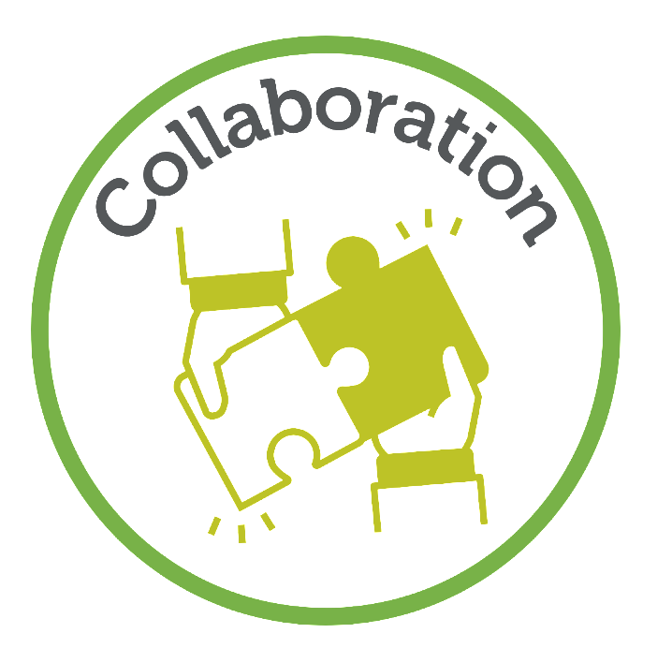 | Challenge  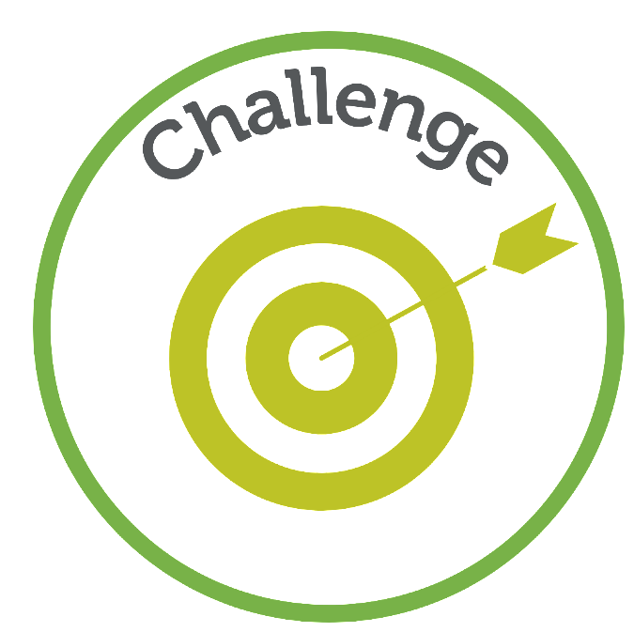 | Compassion  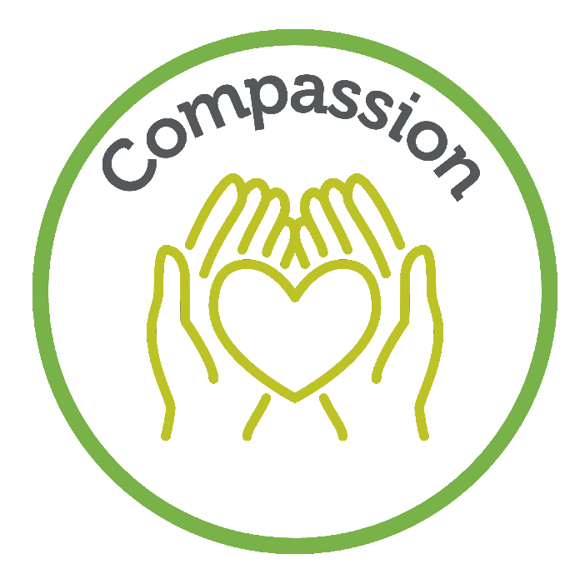

Our Curriculum Threads
International Learners | Aspirational Leaders | Literacy Champions

Characteristics of Effective Learning
Playing and exploring: - Children investigate and experience things, and ‘have a go’. Children who actively participate in their own play develop a larger store of information and experiences to draw on which positively supports their learning
Active learning: - Children concentrate and keep on trying if they encounter difficulties. They are proud of their own achievements. For children to develop into self-regulating, lifelong learners they are required to take ownership, accept challenges and learn persistence.
Creating and thinking critically: - Children develop their own ideas and make links between these ideas. They think flexibly and rationally, drawing on previous experiences which help them to solve problems and reach conclusions.

 | Autumn 1 | Autumn 2 | Spring 1 | Spring 2 | Summer 1 | Summer 2
Topic | Families  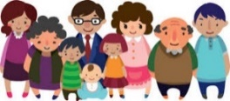 | Celebrations Around the World | Homes | Growing  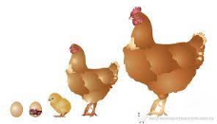 | Animals | Our World  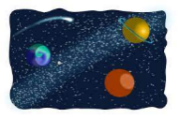
Overview | Transition from N to R  Home family  School family and the community | Exploring Seasonal changes and seasonal celebrations. | Exploring where we and others live | Exploring how things grow and change | Exploring animals in our world, big and small | Exploring our planet and beyond.
Weekly Themes | Settling in and building relationships  Feelings  Where we live  Exploring our families  Our Community - local places to visit  Autumn Seasonal Change | Harvest  Halloween  Bonfire Night  Remembrance Day  Diwali  Christmas  Winter Seasonal Change | New year  Chinese New Year  Being safe  Types of places to live (Countryside, City, Farm and woods)  Homes around the world  Animal Habitats | Spring  Growing and planting  Eggs  Life cycles  When I grow up I want to be a....  How to become a superhero  Pancake day  Mother's Day  Easter | Farmyard Animal  African Animals  Dinosaurs  Taking care of animals  Zoo animals  Endangered animals  Eid-Al-Fitr | Space  The sun  Travelling to space  Protecting our planet  Summer  Transition  Eid- Al-Adha
Super Six Books | Be You!  Big Feelings & What they Tell Us  Not Now Bernard  In Every House on Every Street  Awesome Autumn | Scarecrows Wedding  Room on the Broom  Seasons  A Stroll  Through the Seasons  The Gruffalo  Stickman  Little Robin Red Vest | The Three Little Pigs  Town Mouse, Country Mouse  Rapunzel (Rachel Isadora)  A place Called Home  Home is Where the Heart is.  Goldy Luck and the three pandas (CNY) | Egg to Chicken  Jack and the Beanstalk  Tad  Supertato  A Super Power Like Mine  Rabbit’s Pancake Picnic | The Three billy Goat’s Gruff  Handa’s Surprise  The Dinosaur Department Store  Monkey Puzzle  Poo in the Zoo  Endangered Animals – Who am I? rhymes | The Most Exciting Eid  Toys in Space  Beegu  Whatever Next?  Meet the Planets  Welcome  Clean Up!
Rhyme Time | Days of the Week  Finger Family Song  There were five in a bed  5 current buns in a bakers shop  Autumn Colours Song | Big Red Combine Harvester  Bonfires Burning  Jingle Bells  Five Little Snowmen | Humpty Dumpty  Dragon, Dragon (CNY)  When I walk across the road  In Our House  The House that Jack Built | Five Little Speckled Frogs  Mary, Mary quite contrary  I’m a little bean  The Superhero Parade  Pat-a-cake | Old McDonald Had a farm  Down in the Jungle where nobody’s goes  A dinosaur went stomping one day  Five Little Monkeys | Zoom Zoom  Five Little Men in a Flying Saucer  Climb Aboard  The Sun has got his hat on!
Experiences | Walk around Hale Barns | Nativity  Visit Local Care Home – Sing Carols | Visit China Town in Manchester | Chickens  World Book Day – Library Visit | Chester Zoo Trip | Space Day
Assessment Opportunities | Home Visits  Reception Baseline  WellComm (SALT) Assessments | LW Phonics Assessment  Data Point 1  Pupil progress Meetings | LW Phonics Assessment | Data Point 2  Pupil progress Meetings  LW Phonics Assessment | LW Phonics Assessment | LW Phonics Assessment  Data Point 3  Pupil progress Meetings
Parental Involvement | Stay and play  Phonics Workshop | Parents’ Evening  Nativity Performance | Maths Workshop | Parents’ Evening  Fine Motor skills Workshop | C&L Workshop | Moving on Up Week – stay and play

 | Autumn 1 | Autumn 2 | Spring 1 | Spring 2 | Summer 1 | Summer 2
Topic | Families | Celebrations Around the World | Homes | Growing | Animals | Our World
Communication & Language | The development of children’s spoken language underpins all seven areas of learning and development. Children’s back-and-forth interactions from an early age form the foundations for language and cognitive development. The number and quality of the conversations they have with adults and peers throughout the day in a language-rich environment is crucial. By commenting on what children are interested in or doing, and echoing back what they say with new vocabulary added, practitioners will build children's language effectively. Reading frequently to children, and engaging them actively in stories, non-fiction, rhymes and poems, and then providing them with extensive opportunities to use and embed new words in a range of contexts, will give children the opportunity to thrive. Through conversation, story-telling and role play, where children share their ideas with support and modelling from their teacher, and sensitive questioning that invites them to elaborate, children become comfortable using a rich range of vocabulary and language structures.
 | * To connect one idea or action to another using a range of connectives.  * To engage in storytimes, developing my vocabulary.  * To use new vocabulary in different contexts.  * To listen carefully to rhymes and songs, paying attention to how they sound.  * To join in with whole class activities and concentrate for the duration. e.g. Nursery rhymes, Story Time.  * To follow a routined instruction, e.g. books away, sit on the carpet.  * To respond to a peers  request (e.g. Can I have the ball?) and reply.  * To learn rhymes, poems and songs.  * To listen carefully and understand why listening is important.  * To use simple connectives in speech, e.g. and, but.  * To develop my social phrases. | * To ask questions when I don’t understand instructions.  * To use new vocabulary linked to new learning, for example, changes in materials: ‘dissolving’, ‘drying’, ‘evaporating’; in music: ‘percussion’, ‘tambourine’.  * To offer my ideas in small group contexts.  * To use new vocabulary through the day.  * To have fun saying new words in an exaggerated manner.  * To use full sentences, sometimes with encouragement, to express complete ideas.  * To speak in whole class situations.  * To answer “How” questions. | * To conduct a simple back and forth conversation, paying attention to peer/adult and responding appropriately.  * To show attentive listening skills at input times, e.g. during Phonics, and I am quick to act on instructions.  * To ask questions when I don’t know what a word means.  * To discuss which category a word is in  * To use non-fiction books, to extend my knowledge of the world and illustrate a current topic. | * To ask questions to find out more and to check that I understand what has been said in a variety of contexts.  * To listen to and talk about stories to build familiarity and understanding.  * To use complete sentences in my everyday talk.  * To offer small explanations that demonstrate my understanding on a topic/story.  * To answer “Why” questions. | * To use speech to organise simple activities and problems/conflicts.  * To use talk to help work out problems and organise my thinking and activities, and to explain how things work and why they might happen.  * To articulate my ideas and thoughts in well-formed sentences.  * To use recently modelled language independently, across everyday contexts and all areas of learning. | * To listen to and talk about selected non-fiction, developing a deep familiarity with new knowledge and vocabulary.  * To describe events in some detail. Understanding that it is important to get things in the right order, using sequencing words.  * To retell a story, once I have developed a deep familiarity with the text, using some exact repetition and some in my own words.

 | Autumn 1 | Autumn 2 | Spring 1 | Spring 2 | Summer 1 | Summer 2
Topic | Families | Celebrations Around the World | Homes | Growing | Animals | Our World
Personal, Social & Emotional Development | Children’s personal, social and emotional development (PSED) is crucial for children to lead healthy and happy lives, and is fundamental to their cognitive development. Underpinning their personal development are the important attachments that shape their social world. Strong, warm and supportive relationships with adults enable children to learn how to understand their own feelings and those of others. Children should be supported to manage emotions, develop a positive sense of self, set themselves simple goals, have confidence in their own abilities, to persist and wait for what they want and direct attention as necessary. Through adult modelling and guidance, they will learn how to look after their bodies, including healthy eating, and manage personal needs independently. Through supported interaction with other children, they learn how to make good friendships, co-operate and resolve conflicts peacefully. These attributes will provide a secure platform from which children can achieve at school and in later life.
Managing Self  Self-regulation  Making Relationships | * To express my feelings and give simple reasons about why I feel that way.  *To identify and name some common feelings: surprised, excited, frustrated, upset, cross, lonely, worried  * To follow familiar, routine instructions independently.  * To say ‘please’, ‘thank you’ and ‘excuse me’ at appropriate times.  * To behave appropriately in accordance with the class rules.  * To follow a simple instruction as part of a group, e.g. sit down, let’s go outside.  * To manage my own needs - use the toilet, wash and dry hands.  * To put on and fasten my coat independently (zip, buttons).  * To build constructive and respectful relationships with staff and peers.  * To demonstrate friendly behaviour, with new peers.  Think Equal:  Marvellous Me  These feelings  The weather inside  SEE learning A  Ted the Tiger Tamer | * To consider the feelings of others.  * To talk about why we take turns, wait politely, tidy up after ourselves, use manners and so on.  about when they have felt this way.  * To begin to undress for P.E., with help for buttons.  * To put on and fasten my shoes independently  (buckles, Velcro).  * To talk about why it is important to wash and dry my hands thoroughly. * To take turns with a little support from an adult or with the systems in place, e.g. sand tray  * To try new activities independently, with an adult or with peers.  *To make new and different friends so forming a wider friendship circle  Think Equal:  Anonymouse  Curly the Chameleon  SEE learning B  Ahmed’s Journey  Faisel’s not himself | * To identify strategies for staying calm even when I’m frustrated.  * To recognise when a peer is upset or cross.  * To wait with increased patience, * To make some closer friendships and seek out these friends to initiate play.  * To show kindness towards others by helping, listening and supporting them.  * To join in with a group of children who are playing and listen to their viewpoints and suggestions.  * To be a safe pedestrian and explain what it means to adhere to road safety rules.  * To “bounce back” quicker after upsets and with more independence.  Think Equal:  Biyu the Brave Pea  Thabo and the trees  SEE learning C  Passing Clouds  Yoshi is different | * To explain to an adult what has happened when they are hurt or upset, using descriptive vocabulary.  * I understand how my actions affect other people.  * To discuss the consequences of my behaviour.  when necessary.  * To complete short activities/tasks independently for 10 minutes.  * To take turns in conversation, listen to others views.  *To show empathy in simple ways.  * I understand the importance of sleep and sleep routines.  *Begin to understand that at times my friends will want to play with others but that doesn’t mean they are not my friend.  * To set my own goals and achieve them.  * To discuss healthy food choices and sort healthy foods from less nutritional food.  Think Equal:  Nisha and the Tiger  Francisco’s Family  SEE learning D  Zelda goes on holiday  Monster in the smoke | * I understand that discussion of thoughts is key and I’m beginning to learn that my friends may not always want to play what I want but that’s ok.  * To recognise when my behaviour was not in accordance with the rules and why it is important to respect class rules and behave correctly towards others.  * To begin to solve small conflicts, without adult support, by speaking to my peers and being assertive.  * To initiate conversations and attend to and take account of what others say.  * To identify and model kind and considerate behaviour to both staff and peers.  * To talk about the importance of physical activity on our body and mind.  * To describe myself in positive terms and talk about abilities.-  * To talk about the role of the dentist, what happens when you go to the dentist and why it is important to have your teeth checked.  * To link events (in books, real life etc) with feelings and discuss them.  Think Equal:  Nothando’s journey  Reha to the rescue  My amazing brain A  A tiny seed  My amazing brain B | * To develop my problem solving skills, by talking through how I resolved a problem or difficulty.  * To create rules and codes for behaviour within the classroom.  * To hold back & forth conversations, listening to my peers’ ideas and responding appropriately.  * To explain my own knowledge and understanding, and asks appropriate questions of others.  * To show understanding of another child’s perspective in discussion.  * To follow two-step instructions.  * I am confident to speak to others about own needs, wants, interests and opinions.  * To talk about my work and play, and show perseverance by reflecting and self-evaluating my work.  * To talk about sensible amounts of ‘screen time’.  * To moderate my own feelings when I’ve experienced anger or frustration.  * I understand that it is ok to make mistakes – this is an important part of learning.  * To dress and undress for PE independently.  Think Equal:  Our home  Gokul’s game  My dream in the drawer  Sydney the seahorse

 | Autumn 1 | Autumn 2 | Spring 1 | Spring 2 | Summer 1 | Summer 2
Topic | Families | Celebrations Around the World | Homes | Growing | Animals | Our World
Physical Development | Physical activity is vital in children’s all-round development, enabling them to pursue happy, healthy and active lives. Gross and fine motor experiences develop incrementally throughout early childhood, starting with sensory explorations and the development of a child’s strength, co-ordination and positional awareness through tummy time, crawling and play movement with both objects and adults. By creating games and providing opportunities for play both indoors and outdoors, adults can support children to develop their core strength, stability, balance, spatial awareness, co-ordination and agility. Gross motor skills provide the foundation for developing healthy bodies and social and emotional well-being. Fine motor control and precision helps with hand-eye co-ordination, which is later linked to early literacy. Repeated and varied opportunities to explore and play with small world activities, puzzles, arts and crafts and the practice of using small tools, with feedback and support from adults, allow children to develop proficiency, control and confidence.
Fine Motor | * To use a range of tools competently, safely and confidently.  * To draw circles, horizontal/vertical lines.  * To use a knife and fork to cut food at lunch time.  * To draw simple pictures which can be recognised. | * To use a tripod grip.  * To cut straight lines with scissors.  *To develop strength in fingers to use tweezers /pipettes with control  *To begin to draw anticlockwise circles | *To form letter family patterns  * To form all of the letters of my name correctly. | * To form recognisable letters for the full alphabet. * To use scissors to cut out a simple shape independently.  * To position some letters correctly on a line. | * To form all letters correctly. | * To position all letters correctly on a line.  * To write my first and second name, forming the letters correctly.  *To show accuracy and care when drawing  *To hold a pencil effectively  *To accurately use scissors, brushes and cutlery
Gross Motor | * To move with developing control and grace.  * To travel with more speed and control.  * To use my core muscle strength to achieve a good posture when sitting at a table or sitting on the floor.  * To spin, rock, tilt, slide and bounce.  GetSet4PE  Fundamental skills  Me and my Family  Children learn basic principles of a PE lesson such as safely using space, stopping safely, using and sharing equipment and working individually, with a partner and group. They develop skills of running, jumping and skipping. Children play simple games and begin to understand and use rules. | * To balance and ride on a two-wheeled balance bike.  * To run fast and stop on request.  * To jump over a line.  * To throw, catch and aim large balls.  GetSet4PE  Gymnastics  Traditional Tales  Children explore basic movement, creating shapes, balances, and jumps and rolls. They safely and perform basic skills on both floor and apparatus. They copy, create, remember and repeat short sequences beginning to use levels. | * To use physical skills like lifting, carrying, pushing, pulling, constructing, stacking and climbing.  * To quickly change speed and direction.  *To combine different movements to complete more demanding obstacle courses  GetSet4PE  Dance - Journeys  Children develop their expressive movement. They explore travelling movements, shapes and balances. They choose their own actions in response to a stimulus. They copy, repeat and remember actions. They are introduced to counting to help them keep in time. They perform to others and begin to provide simple feedback. | * To balance and engage in dance, gymnastics and sport.  * To throw, catch and aim small balls  *To use a range of resources to bat/pat/hit a ball  *To hang and swing from bars/ balance/ climb using full body strength.  GetSet4PE  Games - Transport  Children develop their understanding of playing games and further develop fundamental movement skills. They learn how to score and play by the rules, how to work with a partner and begin to understand what a team is, as well as learning how to behave when winning and losing. | * To balance and ride on a two-wheeled pedal bike without stabilisers.  *To join in group activities with rules, developing precision using bat and ball skills  GetSet4PE  Ball skills  Weather  Children will develop fundamental ball skills such as throwing and catching, rolling a ball, using targets, dribbling with feet, kicking a ball, bouncing and catching a ball. They develop their fine and gross motor skills though a range of game play with balls. They work independently and with a partner developing decision making and using simple tactics. | * To confidently and safely use a range of large and small apparatus indoors and outside, alone and in a group.  (GYM)  *To consider others when negotiating space.  *To show strength, balance and co-ordination  *To move energetically eg dancing, skipping.  GetSet4PE  Games – The World  Children learn and develop skills by playing a variety of games. They will also start to understand how to work as a team, take turns, keep the score, play against an opponent and play by the rules.

 | Autumn 1 | Autumn 2 | Spring 1 | Spring 2 | Summer 1 | Summer 2
Topic | Families | Celebrations Around the World | Homes | Growing | Animals | Our World
Reading | It is crucial for children to develop a life-long love of reading. Reading consists of two dimensions: language comprehension and word reading. Language comprehension (necessary for both reading and writing) starts from birth. It only develops when adults talk with children about the world around them and the books (stories and non-fiction) they read with them, and enjoy rhymes, poems and songs together. Skilled word reading, taught later, involves both the speedy working out of the pronunciation of unfamiliar printed words (decoding) and the speedy recognition of familiar printed words. Writing involves transcription (spelling and handwriting) and composition (articulating ideas and structuring them in speech, before writing).
Comprehension  - Developing a passion for reading | * To recount simple story.  * To begin to answer why questions.  * To talk about my favourite stories and know books are written.  *To show interest in Non-fiction books e.g. I love fire engines and therefore want to read a book about fire engines. | * To use the correct vocabulary to name text related concepts, for example: character, setting, beginning and end.  * To sequence three or more events from a story.  * To provide simple reasons for actions and events.  *To show interest in Non-fiction books e.g. I love fire engines and therefore want to read a book about fire engines. | * To understand story ‘middles’, eg: problem, event and how they are solved at the end.  * To show interest in Non-fiction books e.g. I love fire engines and therefore want to read a book about fire engines.  * To start to retell verbally main events of a well-known story. | * I am beginning to reason and explain events answering how questions.  * I am beginning to imagine and speculate ‘What if….? ‘questions.  * To peruse books for pleasure and start to choose books independently.  * To relate some stories to my own experiences. | * To recount simple stories, looking for patterns and be able to ask questions about what happened before. | * To use the terms: author, illustrator, blurb, contents page and index.  * To retell stories in my own words, using recently introduced vocabulary.
Word Reading | * To read individual letters by saying the sounds for them.  * To begin to blend sounds into words  *To read short words made up of known letter– sound correspondences.  * To recognise labels in my classroom environment.  Little Wandle  Phase 2 Graphemes:  s a t p i n m d g o c k ck e u r h b f l  Tricky Words  is I the | * To read some letter groups that each represent one sound and say sounds for them.  * To read a few common exception words matched to the school’s phonic programme.  Little Wandle  Phase 2 Graphemes:  ff ll ss j v w x y z zz qu ch sh th ng n_  • words with –s /s/ added at the end (hats sits)  • words ending in s /z/ (his) and with –s /z/ added at the  end (bags sings)  Tricky Words  put* pull* full* as and has his her go no to into she  push* he of we me be | * To read simple phrases and sentences made up of words with known letter–sound correspondences and, where necessary, a few exception words.  Little Wandle:  Phase 3 Graphemes:  ai ee igh oa oo oo ar or ur ow oi ear air er  • words with double letters  • longer words  Tricky Words  was you they my by all are sure pure | * To re-read books to build up my confidence in word reading, my fluency and my understanding and enjoyment.  Little Wandle:  Phase 3 Graphemes:  Review Phase 3  • words with double letters, longer words, words with two  or more digraphs, words ending in –ing, compound words  • words with s /z/ in the middle  • words with –s /s/ /z/ at the end  • words with –es /z/ at the end  Tricky Words  Review all taught so far | * To say a sound for each letter in the alphabet and at least 10 digraphs.  Little Wandle:  Phase 4 Graphemes:  Short vowels with adjacent consonants  • CVCC CCVC CCVCC CCCVC CCCVCC  • longer words and compound words  • words ending in suf_xes:  –ing, –ed /t/, –ed /id/ /ed/, –est  Tricky Words  said so have li_e some come love do were here little  says there when what one out today | * To read words that are consistent with my phonic knowledge by sound-blending.  * To read aloud simple sentences and books that are consistent with my phonic knowledge, including some common exception words.  Little Wandle:  Phase 4 Graphemes:  Phase 3 long vowel graphemes with adjacent consonants  • CVCC CCVC CCCVC CCV CCVCC  • words ending in suf_xes:  –ing, –ed /t/, –ed /id/ /ed/, –ed /d/ –er, –est  • longer words  Tricky Words  Review all taught so far

 | Autumn 1 | Autumn 2 | Spring 1 | Spring 2 | Summer 1 | Summer 2
Topic | Families | Celebrations Around the World | Homes | Growing | Animals | Our World
Writing | It is crucial for children to develop a life-long love of reading. Reading consists of two dimensions: language comprehension and word reading. Language comprehension (necessary for both reading and writing) starts from birth. It only develops when adults talk with children about the world around them and the books (stories and non-fiction) they read with them, and enjoy rhymes, poems and songs together. Skilled word reading, taught later, involves both the speedy working out of the pronunciation of unfamiliar printed words (decoding) and the speedy recognition of familiar printed words. Writing involves transcription (spelling and handwriting) and composition (articulating ideas and structuring them in speech, before writing).
Physical and Technical  (Handwriting) | * To begin to form/ write some graphemes correctly.  * To sit correctly with good posture when seated at a table to write. | * To use a tripod grip.  * To use common capital letters for my names and given texts e.g I, ‘T’ as in : The…. | * To begin to form lower-case correctly.  *I am starting to position all letters correctly on a line. | * To position all letters correctly on a line.  * To form capital letters correctly. | *To position all letters correctly on a line.  * To form capital letters correctly. | *To position all letters correctly on a line.  * To form capital letters correctly.
Physical and Technical  (Transcription) | * To write simple vc words. | * To write simple cvc words.  * To write simple common words. Eg: I, Mum, Dad, Nana. | * To write short sentences with words with known sound-letter correspondences. | *To use my increasing bank of sight vocabulary in my independent writing from memory.  * I am using plausible phonetical spelling of unfamiliar words in my writing. | * To write short sentences with words with known sound-letter correspondences and taught digraphs  *To spell known common exception words | * To write short sentences with words with known sound-letter correspondences and known digraphs  *To spell known common exception words
Develop Communication and Meaning  (Composition) |  | * To construct simple sentences supported by adults scribing, copy writing/ sentence building | * To write labels and captions independently.  * To create simple phrases with meaning (I went to … To…).  * To construct a simple sentence, writing the initial and end sounds in words. | * To think of imaginary sentences.  * To re-read what I have written to check that it makes sense.  * I am beginning to use full stops and letter spacing. | * To use a full stop.  * To use finger spaces.  * To write a short sentence, without support. | * To use and to extend my short sentence.  * To read my sentence to you.  * I know you will be able to read my writing and understand it.

 | Autumn 1 | Autumn 2 | Spring 1 | Spring 2 | Summer 1 | Summer 2
Topic | Families | Celebrations Around the World | Homes | Growing | Animals | Our World
Maths | Developing a strong grounding in number is essential so that all children develop the necessary building blocks to excel mathematically. Children should be able to count confidently, develop a deep understanding of the numbers to 10, the relationships between them and the patterns within those numbers. By providing frequent and varied opportunities to build and apply this understanding - such as using manipulatives, including small pebbles and tens frames for organising counting - children will develop a secure base of knowledge and vocabulary from which mastery of mathematics is built. In addition, it is important that the curriculum includes rich opportunities for children to develop their spatial reasoning skills across all areas of mathematics including shape, space and measures. It is important that children develop positive attitudes and interests in mathematics, look for patterns and relationships, spot connections, ‘have a go’, talk to adults and peers about what they notice and not be afraid to make mistakes.
Number and numerical patterns | * To count objects, actions and sounds, saying the numbers in order and matching one number name to each item.  * To record quantities in different ways such as tallies.  * Play games that involve counting.  *To sing number songs (counting to 20)  *Compare amounts using vocabulary more/fewer and the same  WRM  Match, Sort & Compare | * To count out a smaller number from a larger group: ‘give me seven’.  * To recognise small quantities in different arrangements – subitising.  * To link the number symbol (numeral) with its cardinal number value  * I understand the ‘one more than/one less than’ relationships between consecutive numbers, making predictions about what the outcome will be in stories, rhymes and songs if one is added or taken away.  * Compare numbers, using the vocabulary of more than, less than, fewer, the same as, equal to.  * To use five frames and ten frames, learning the structure of the number system.  * To estimate a total before counting.  WRM  It’s Me 1, 2, 3  1, 2, 3, 4, 5 | * To count by rote to 20.  * To count back from 10.  *4  WRM  Alive in 5  Growing 6, 7, 8 | * To count on from a given number to 20.  * To discuss composition of numbers to 10, showing some recall of number facts.  * To subtract single digit numbers.  * Count beyond 10, counting verbally beyond 20.  WRM  Building 9 & 10 | * To subtract to 10.  * To double numbers.  * To share objects between 2.  * Exploring the composition of numbers to 10 through subitising, doubling and partitioning.  *Explore and represent patterns within numbers up to 10, including evens and odds  * To use the number bonds to 10 to solve problems.  WRM  To 20 and beyond  How many now? | * To talk about the odd and even numbers to 10.  * Have a deep understanding of number to 10, including the composition of each number.  * Automatically recall number bonds up to 5 and some number bonds to 10, including double facts.  * Explore and represent patterns within numbers up to 10, including even and odds.  *Verbally count beyond 20, recognising the patterns of the counting system.  WRM  Sharing & Grouping  Consolidation
Shape and Space | * To select, rotate and manipulate shapes in order to develop spatial reasoning skills.  * To continue, copy and create repeating patterns: AB, ABB patterns.  * To recite the days of the week/months.  * I am beginning to understand yesterday, today, tomorrow.  *Compare length, weight and capacity using comparative language using ‘than’.  WRM  Talk about Measure & Patterns | * To find 2D shapes within 3D shapes.  * To make a direct comparison using tall and short.  * To understand and use the language: next to, between, below, above, under, in front, behind, close to, far away.  *Continue, copy and create repeating patterns: ABBC patterns.  *Compare length, weight and capacity using comparative language using ‘than’.  WRM  Circles & Triangles  Shapes with four sides | * To make my own ABBC pattern.  * To understand morning, afternoon, day, night.  * To order a simple sequence of events.  * To identify straight and curved sides on 2D shapes and flat and curved faces on 3D shapes.  *Use everyday language to discuss length, size, height, weight, time, position and capacity. Use this language to make simple observations, e.g. this is heavier than that.  WRM  Length, Height & Time | * To identify and name 3D shapes (cylinder, cube, cuboid, sphere) talk about their properties.  * To use language and make direct comparisons of capacity.  * Understand and use correct mathematical language to describe 2D and 3D shapes (e.g., vertices, sides, edges, faces, flat, curved).  *Make predictions and link their knowledge of number to their work on measures, e.g. The red car weighed 4 cubes and the green one is heavier so it might weigh 6 cubes.  * To make my own ABBC pattern.  WRM  Explore 3-D shapes | * To compose and decompose shapes so that children recognise a shape can have other shapes within it, investigate how shape can be combined to make new shapes.  WRM  Manipulate, compose and decompose | * To create a pattern that has a fixed number of spaces.  * To understand and use the words: near, far, direction, left, right, towards, fast, slow, nearest, furthest.  * To use language and make direct comparisons of weight.  WRM  Visualise, build & map

 | Autumn 1 | Autumn 2 | Spring 1 | Spring 2 | Summer 1 | Summer 2
Topic | Families | Celebrations Around the World | Homes | Growing | Animals | Our World
Understanding the World  Natural World | Understanding the world involves guiding children to make sense of their physical world and their community. The frequency and range of children’s personal experiences increases their knowledge and sense of the world around them – from visiting parks, libraries and museums to meeting important members of society such as police officers, nurses and firefighters. In addition, listening to a broad selection of stories, non-fiction, rhymes and poems will foster their understanding of our culturally, socially, technologically and ecologically diverse world. As well as building important knowledge, this extends their familiarity with words that support understanding across domains. Enriching and widening children’s vocabulary will support later reading comprehension.*
 | * To recall common weather patterns and notice patterns/clusters in weekly weather.  *To describe what they see, hear and feel outside, such as plants/animals | * To identify and name common native, woodland, countryside creatures. Talking about where they live, what they might eat.  * To tell you about some creatures that are active at night and that some go to sleep in the winter.  *Through stories and first hand experiences notice the effect of changing seasons on the natural world around me (frosty grass, bare trees)  * To use accurate/scientific language to describe features of weather (mostly cloudy, heavy rain, hot sunshine, light breeze, stormy winds)  * To talk about how Summer changes into Autumn. | * To talk about the natural world around me (buds, new growth, puddles)  *Explore through their senses and increasing range of materials and describe their characteristics  *Record daily weather patterns and notice daily changes  *Children notice how some materials/food change when cooked (soften – veg, harden – cake mix, set – jelly) | * To name daffodils, snowdrops, dandelions, daisies, buttercups.  *Ask and answer questions to help understand that vegetables grow, fruit comes from trees and other plants, flour comes from wheat.  * I understand very simple features of the life cycle of creatures hatching from eggs (birds – chicken, frogs).  * To name and investigate using my senses an increasing range of plants that give us food  * To talk about how Winter changes into Spring.  * To describe and explore ‘properties’ of food (runny, wobbly, fizzy, hot, cold, simple tastes; sweet, salty) Mashing, squashing, sloppy, liquid, stretch  * To explain that seeds grow into plants.  *Observe beans sprouting roots, find examples of roots and stems outside | *Through stories, pictures and first hand experiences name a wider range of animals including groups of animals such as birds, reptiles and animals from different habitats.  * To name, observe and draw animals with common features.  * To talk about the features of animals that live in similar places and suggest reasons why.  *Explore the natural world around them, making observations and drawing pictures of animals and plants  * I understand very simple features of the life cycle of creatures hatching from eggs (reptiles – dinosaurs) | * To use my senses outside to explore shadows.  * To talk about the danger of looking directly at the sun.  * To talk about rubbish and the importance of recycling: identify materials that do not belong – litter  * To talk about how people mess up the world and what they do to look after it.  *Use their senses outside to explore shadows, light and dark, bright and dull
People, Communities & Culture | * To talk about, use pictures and use stories to explain which times are special to me and why.  *To talk about members of their immediate family and community  * Children explore and begin to understand the use of: playgrounds, parks, shops, library, doctors, dentist in our local area.  * To describe the environment where I live.  * To talk about the people who help us in our community.  *To draw information from a simple map  * I know that some environments are different to where I live  * To talk about my journey to and from school and discuss what they see en-route. Teachers model how to draw information from a simple map, starting with a whole class map of the local area and track journeys of children’s houses in relation to distances from school  * To talk about the different journeys, I make. | * To recognise that people have different beliefs and have special stories that are important to them  *To understand the purpose of places of worship, drawing on their own experiences.  * Through stories and pictures, recognise some similarities and differences between life in this country and life and celebrations around the world and in different countries. (Halloween, Bonfire night, Diwali, Hanukah, Christmas) | * To draw pictures of my house, school and other places in my local environment.  *To discuss and explain journeys they take in small world play, children to use carpet maps to role play different journeys  * Through stories and pictures, recognise some similarities and differences between life in this country and life and celebrations around the world and in different countries. (Chinese New Year) ( |  | * To talk about things I find interesting, puzzling or wonderful.  * To talk about some similarities and differences between different religious and cultural communities in this country. | * To talk about some similarities and differences between different religious and cultural communities in this country.  * To discuss holidays and places I have been beyond my local community.  *To explain some similarities and differences between life in this country and life in other countries  *Describe their immediate environment using knowledge from observation, discussion, stories, non-fiction texts and maps
Past & Present | *To comment on images of familiar situations in the past  * To talk about the roles people have in my community  * To talk about familiar situations from the past, looking at photos of the school and locality. |  |  | * To talk about traditional stories from the past. | * To talk about some similarities and differences between things in the past and now (animals that have become extinct like dinosaurs) | * I understand the past through characters and events in books and storytelling.  *To talk about and organise events, recognising that things happened before they were born.
RE Festivals | Harvest | Bonfire Night  Remembrance Day  Hanukkah  Christmas Day  Diwali | Chinese New Year  Shrove Tuesday  St. David’s Day | Ramadan  Easter | Eid-Al-Fitr | Eid- Al-Adha

 | Autumn 1 | Autumn 2 | Spring 1 | Spring 2 | Summer 1 | Summer 2
Topic | Families | Celebrations Around the World | Homes | Growing | Animals | Our World
Expressive Arts and Design | The development of children’s artistic and cultural awareness supports their imagination and creativity. It is important that children have regular opportunities to engage with the arts, enabling them to explore and play with a wide range of media and materials. The quality and variety of what children see, hear and participate in is crucial for developing their understanding, self-expression, vocabulary and ability to communicate through the arts. The frequency, repetition and depth of their experiences are fundamental to their progress in interpreting and appreciating what they hear, respond to and observe.
Creating with materials | * To draw a self-portrait.  * To use colours for a purpose. (PAINTING)  * To draw bodies of an appropriate size when representing my family.  * To use different size brushes, selecting fine brushes to add detail.  * To develop simple patterns by printing with objects using range of materials.  * To use paints and brushes to make a range of marks – dots, dabs, zig zags, wavy.  * To return to and build on my previous learning, refining ideas  * To adapt my construction to achieve a desired outcome.  * To construct with a purpose in mind, using a variety of resources. | * To name the primary colours.  * To mix two colours to make the secondary colours.  * To mix colours and know the colour I want to create.  * To use a painting programme on the computer or iPad.  * To create work in the style of Kadinsky  * To create different textures and combine media to create new effects.  * To manipulate clay and use a simple technique to achieve a planned effect.  * To construct with a purpose in mind, using a variety of resources. | * To use larger scale loose parts to create.  * To create collaboratively, sharing ideas, resources and skills.  * To improve my models.  * To participate in collaborative, creative activities.  * To use rolled up paper and art-straws, pipe cleaners to create structures and objects. | * To select tools and techniques needed to shape, assemble and join materials.  * To work in a group to create a 3D model, using materials such as paper to add extra detail. | * To mix colours and know how to change the shade of colour.  * To weave with fabrics. orange netting, garden netting.  * To use a variety of art tools with greater accuracy.  * To draw into clay with simple tools.  * To choose materials to achieve a goal. (MATERIALS) | * To explain how I created something to my peers including why I chose a particular technique/material and how it is fit for purpose.  * To return to and extend my creative learning.
Being Imaginative and expressive | * To sing in a group or on my own, matching the pitch and following the melody.  * To request a favourite rhyme,  * To sing along to favourite pop songs.  * To develop storylines in my pretend play.  * To develop storylines through small-world or role-play with peers.  * To create my own beats with musical instruments/body percussion.  * To listen to music and talk about how it makes me feel.  * To sing songs from own culture in home language and share with others. | * I know and join in with nursery rhymes and favourite songs.  * To make up my own songs.  * To take part in simple, pretend play often based on familiar experiences.  * To play cooperatively as part of a group to develop and act out a narrative.  * To listen to music and talk about how it makes me feel. | * To change a song/rhyme to create a desired effect. Sing the Humpty Dumpty Rap.  * To use enhancements to extend my imaginative play.  * To use fabric, boxes, tubes and joining materials to make props.  * To talk about my favourite music or song and why I like it. | * To sing songs from own culture in home language and share with others.  * To use different materials (larger sizes), to add to costumes and make my own.  * To move my body in an expressive way to music | * To perform familiar songs/rhymes in a small group.  * To create more complex narratives in my pretend play, building on the contributions of my peers.  *Listen attentively, move to and talk about music, expressing their feelings and responses.  * Watch and talk about dance and performance art, expressing their feelings and responses.  *Sing in a group or on their own, increasingly matching the pitch and following the melody.  * Develop storylines in their pretend play.  * Explore and engage in music making and dance, performing solo or in groups. | * To retell parts of familiar stories through use of puppets, toys, masks or small-world.  * To engage in music and follow a story map creating a musical accompaniment.  * To perform in a performance.  * To dance in a sequence of learnt moves.

